Study Guide: SHOT TYPES
MCU (MEDIUM CLOSE UP) CHEST UP

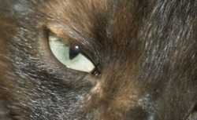 ECU (EXTREME CLOSE UP) * DETAIL /VERY CLOSE*

CLOSE UP (CU) *NECK UP

WS (WIDE SHOT) *FULL BODY

EXTREME WIDE SHOT (EWS) *ENTIRE SETTING

MS (MID SHOT) *WAIST OR KNEES UP
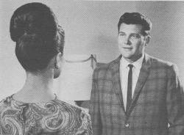 OTS (OVER THE SHOULDER)
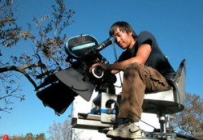 HIGH ANGLE
POV (POINT OF VIEW) * THE CAMERA IS SUBJECT’S PERSPECTIVE*
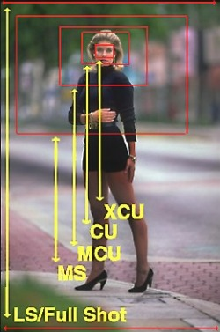 ALL VARIOUS SHOTS
**LONG SHOT IS A NARROW SHOT* (THINK HALLWAY)

